MEDICAL EQUIPMENT LOAN FORM
**Financial donations gratefully accepted**
The medical equipment borrowed from Better Health of Cumberland County, Inc. is on Temporary Loan for six months (exception: wheelchair for 3 months). When the loaned item is no longer needed, please return it as soon as possible, so that it will be available for the next person who needs it. A volunteer may call to check on the equipment periodically. Please complete all information.

INDIVIDUAL USING EQUIPMENT

Name: Social Security Number (last 4 digits):

Address:
# and Street Name City Zip Code

Phone: Sex: Race: Date of Birth:

Client has been discharged from hospital or emergency room within the 7 days (circle): Yes No

# in Household: Household Monthly Income: Medical Insurance:

Equipment Borrowed:

Projected Date of Equipment Return:

REFERENCES
(Must be Cumberland County Residents)

- Name: Phone:

Address:

- Name: Phone:

Address:

INDIVIDUAL BORROWING EQUIPMENT
(Complete only if different than person using equipment.)
Name:

Address:

Phone: Agency:

The undersigned acknowledges and agrees that this equipment is NOT warranted by Better Health of Cumberland County, Inc. against possible malfunction or need of repair and accepts the equipment “AS IS” and fully releases and discharges Better Health of Cumberland County, Inc from any liability for any malfunction or disrepair of the equipment. It is understood that this equipment is on temporary loan and should it not be returned to Better Health of Cumberland County, Inc., I am responsible for the cost of purchasing a replacement.

Signature: Date: NCDL#:
(Back of form must be signed also.)

Date Returned: Received by:
STATE OF NORTH CAROLINA
RELEASE
COUNTY OF CUMBERLAND

The undersigned, , has requested the use of equipment from Better Health of Cumberland County (BHCC); and for and in consideration of using said equipment, the undersigned hereby for himself and his heirs, executors, administrators, successors and assigns, forever releases, acquits, discharges, and holds harmless Better Health of Cumberland County, and its employees, officers, officials, and agents from any and all claims, causes of action, or demands for personal injury or property damage arising out of the negligence of the employees, officers, officials, and agents of Better Health of Cumberland County for any liability arising out of the delivery and/or pickup or use of said equipment. I understand that it is my responsibility to regularly inspect the equipment to ensure it is in sound, safe working condition and that Better Health can not ensure the condition of donated equipment.

This the day of , .

(Recipient Signature) (Date)

(Recipient Name Printed)

(BHCC Authorized Representative) (Date)

(BHCC Name Printed)

Better Health of Cumberland County
1422 Bragg Boulevard
Fayetteville, NC 28301
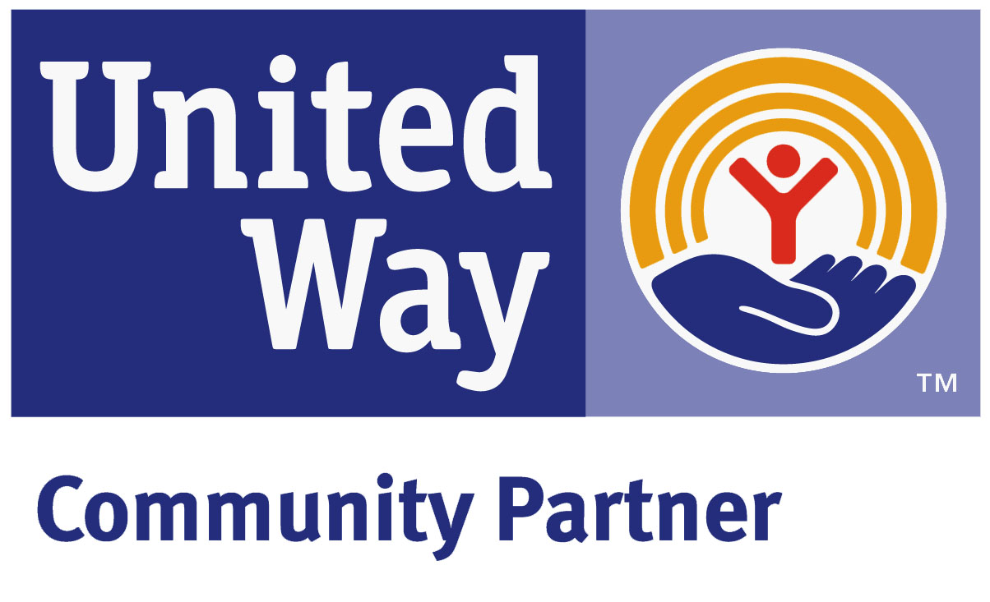 Phone: (910) 483-7534 FAX: (910) 483-2157

