Better Health of Cumberland County, Inc.
Volunteer Application Form

Date of Application:

Name:
Last First Middle Initial

Home Address:
Street/PO Box City State Zip Code

Home Phone: Cell Phone: Birthdate:

Place of Employment: E-mail

Please indicate the type of volunteer service you would like to offer:

Computer data entry TCOD volunteer
General office duties Phone calls
Spanish translator Clinic volunteer
Committee member Medical equipment maintenance
Diabetes screening nurse Fayetteville Fit presenter
Diabetes class instructor (licensed medical professional)

Any additional training and/or skills you would be willing to share (prior volunteer experience, etc.)

Clinical Licensure (please be prepared to present for copying into file)

Times and Days available:

*once submitted we will be in contact to schedule an orientation

Diabetes Education • Financial Assistance • Medical Equipment Loan
Founded 1958
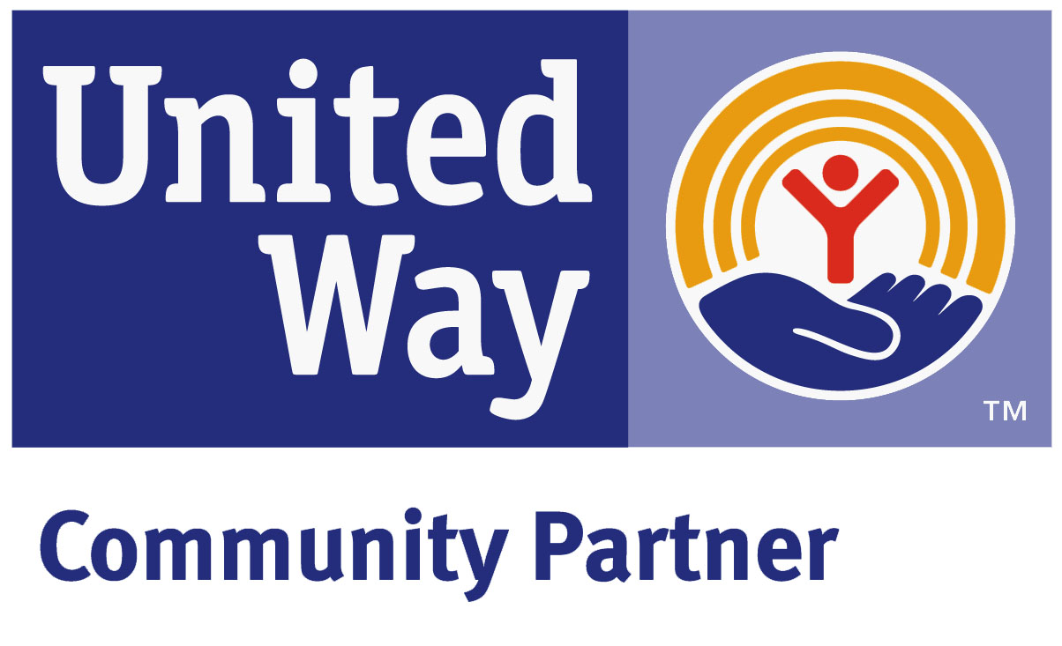
1422 Bragg Blvd. • Fayetteville, NC 28303
Phone 910•483•7534 or FAX 910•483•2157
www.BetterHealthCC.org
Volunteer Confidentiality Statement

Patient Privacy – the right of the patient/client to decide what personal health information can be shared with others, how that information can be shared and with whom and the right not to have information about him/her discussed in areas where other people can overhear.
Patient confidentiality – a patient/client’s trust that personal health information will only be shared with those who have a need to know in order to provide appropriate care.
To help protect patient privacy and confidentiality consider the following:
- Think before you speak to another individual about a client and consider the following two questions.
  - Do I/they want to know this information, or do I/they need to know?
  - Do I/they have a right to know this information?
- Be aware of whether others can overhear conversations.
- If you think that certain information might be confidential, treat it as such.
- Treat all clients with respect.
- Respect every patient/client’s right to privacy.
I promise to hold in confidence all information regarding clients, donors, staff, and community contacts of Better Health. I will not violate the confidential relationships between the programs, their clientele, staff, community contacts and volunteers.
I will not remove from the office any written records or copies thereof. Any written records I may be responsible for producing shall be and remain part of the program files. All electronic documents or lists created or obtained in the course of my volunteer work shall be relinquished to Better Health upon completion of volunteer hours or request of the Executive Director.
I accept full responsibility for maintaining the confidential and private nature of all records and information. I further understand that I can discuss cases assigned to me only with my designated supervisor and/or designated administrator.
I understand that I am personally responsible and fully liable for any violation of this agreement.

Volunteer’s Signature Date

Supervisor’s Signature Date

STATE OF NORTH CAROLINA RELEASE
COUNTY OF CUMBERLAND

The undersigned, , has volunteered his/her services to Better Health of Cumberland County (BHCC) for the period to ; and for and in consideration of BHCC’s acceptance of this support, the undersigned hereby for himself and his heirs, executors, administrators, successors and assigns, forever releases, acquits, discharges, and hold harmless Better Health of Cumberland County, and its employees, officers, officials, and agents from any and all claims, causes of action, or demands for personal injury or property damage arising out of the negligence of the employees, officers, officials, and agents of Better Health of Cumberland County for any liability arising out of the services provided by volunteer. This the day of , .

(Volunteer Signature/Printed) (Date)

(BHCC Authorized Representative Signature/Printed) (Date)

