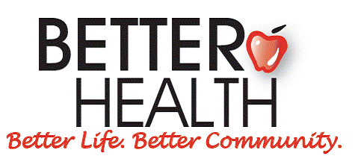

Information for Potential Board Members

Thank you for your interest in the Board of Directors at Better Health!

Better Health was established in 1958 to purchase life sustaining pharmaceuticals for needy Cumberland County residents. Our mission is to address the unmet healthcare needs of Cumberland County residents through education, referral, and assistance.

Our programs include:
- Diabetes management
- Direct aid (prescription, travel, dental assistance, etc.)
- Medical equipment loan closet
- Childhood obesity prevention

Financial support comes from the United Way, individual donors, sponsors and grants.

Board member involvement includes:
- A brief orientation
- Regular attendance at Board meetings
- Participation on one standing committee and one fundraising committee
- Help setting the precedent for other donors by regularly contributing at whatever level is significant to you

Board terms are for 3 years, but may be renewed once for an additional 3 years.

Directors are chosen by a vote of the current Board.

We encourage you to visit our website to learn more!
www.betterhealthcc.org

Contact Executive Director Amy Navejas with questions or if you would like to be considered for the Board of Directors!

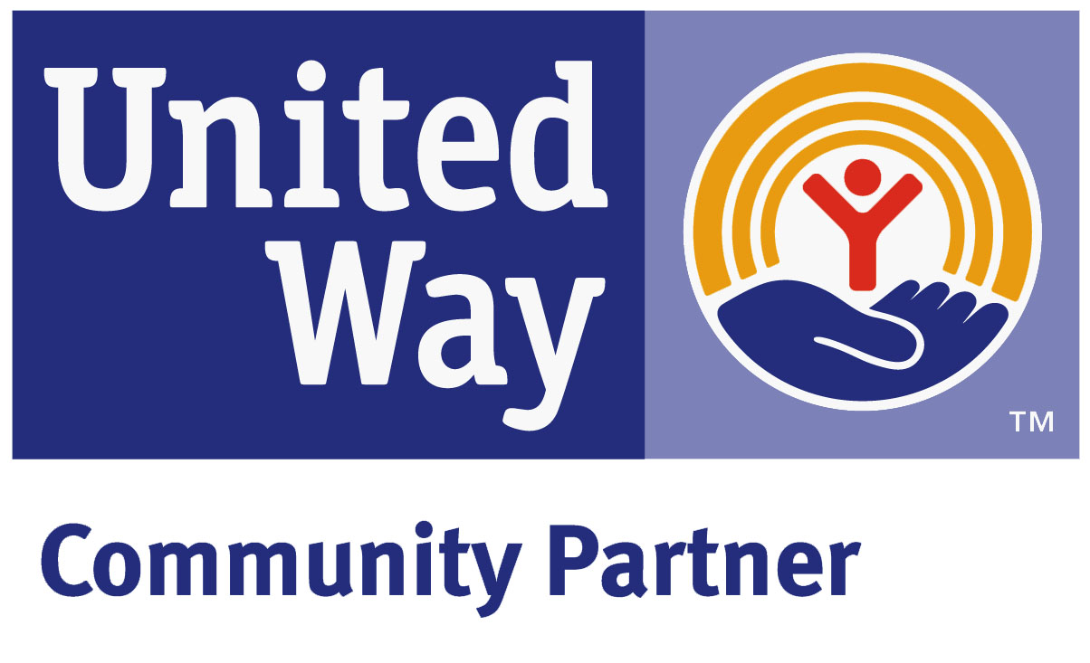
1422 Bragg Blvd. • Fayetteville, NC 28303
Phone 910•483•7534 or FAX 910•483•2157
www.BetterHealthCC.org

Information for Potential Board Members

Thank you for your interest in the Board of Directors at Better Health!

Better Health was established in 1958 to purchase life sustaining pharmaceuticals for needy Cumberland County residents. Our mission is to address the unmet healthcare needs of Cumberland County residents through education, referral, and assistance.

Our programs include:
- Diabetes management
- Direct aid (prescription, travel, dental assistance, etc.)
- Medical equipment loan closet
- Childhood obesity prevention

Financial support comes from the United Way, individual donors, sponsors and grants.

Board member involvement includes:
- A brief orientation
- Regular attendance at Board meetings
- Participation on one standing committee and one fundraising committee
- Help setting the precedent for other donors by regularly contributing at whatever level is significant to you

Board terms are for 3 years, but may be renewed once for an additional 3 years.

Directors are chosen by a vote of the current Board.

We encourage you to visit our website to learn more!
www.betterhealthcc.org

Contact Executive Director Amy Navejas with questions or if you would like to be considered for the Board of Directors!

1422 Bragg Blvd. • Fayetteville, NC 28303
Phone 910•483•7534 or FAX 910•483•2157
www.BetterHealthCC.org

